Your Publication Title

Some subtitle text

First Author

Second Author

Third Author

Abstract

“some abstract text. Lorem markdownum natale egressus congestaque rogant. Eadem sors reddidit et *certe sol duobus*, tethys, inducitur subit: tuum qui. Lyrnesia hunc leti tuam *lacrimis dedere* serpentis vacca rectorque concurrere solum, qua illa. Miraturus a harenas mihique summa quem hanc, lacrimis est propiore fecit, causam eadem rubentem quoque! Cunctaque maestae ore: sedit adsuetudine verba inventa imagine atrae extemplo”

# Introduction

Lorem markdownum natale egressus congestaque rogant. Eadem sors reddidit et *certe sol duobus*, tethys, inducitur subit: tuum qui. Lyrnesia hunc leti tuam *lacrimis dedere* serpentis vacca rectorque concurrere solum, qua illa. Miraturus a harenas mihique summa quem hanc, lacrimis est propiore fecit, causam eadem **rubentem quoque!** Cunctaque maestae [inter duodena](http://iter.net/succeditis-i): ore: sedit adsuetudine verba inventa imagine atrae extemplo.

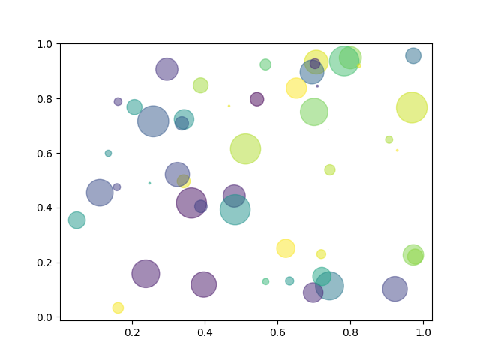

Figure 1: Example for including graphs or images in your publication.

link to image (Fig. 1)

### Citations

This is a citation for testing purposes1

And another one just to have some more in the biblographic listing2

### Group of images

A group of images can be created using a HTML <div> .... </div> block. An identifier to reference the figure can be added to the opening <div> statement by adding id="fig:figureRef" where figureRef can be replaced by an arbitrary identifier name.

|  |
| --- |
| a b |

Figure 2: Caption of figure. a — subfigure 1 caption, b — subfigure 2 caption

# Experimental

Link to a section with a label suppressing the prefix *Section* to show only the label: Introduction

Same link but without suppressing the prefix: Section Introduction

## Tables

Table 1: This is a dummy table caption

| a | b | c |
| --- | --- | --- |
| 1 | 2 | 3 |
| 4 | 5 | 6 |

# Appendix

# List of Figures

1. Example for including graphs or images in your publication.

2. Caption of figure

2 (a). subfigure 1 caption

2 (b). subfigure 2 caption

# List of Tables

1. This is a dummy table caption

## Bibliography

(1) Abbas, S.; Hwang, J.; Kim, H.; Chae, S. A.; Kim, J. W.; Mehboob, S.; Ahn, A.; Han, O. H.; Ha, H. Y. Enzyme-Inspired Formulation of the Electrolyte for Stable and Efficient Vanadium Redox Flow Batteries at High Temperatures. *ACS Appl. Mater. Interfaces* **2019**, *11* (30), 26842–26853. <https://doi.org/10.1021/acsami.9b06790>.

(2) Albertus, P.; Manser, J. S.; Litzelman, S. Long-Duration Electricity Storage Applications, Economics, and Technologies. *Joule* **2020**, *4* (1), 21–32. <https://doi.org/10.1016/j.joule.2019.11.009>.